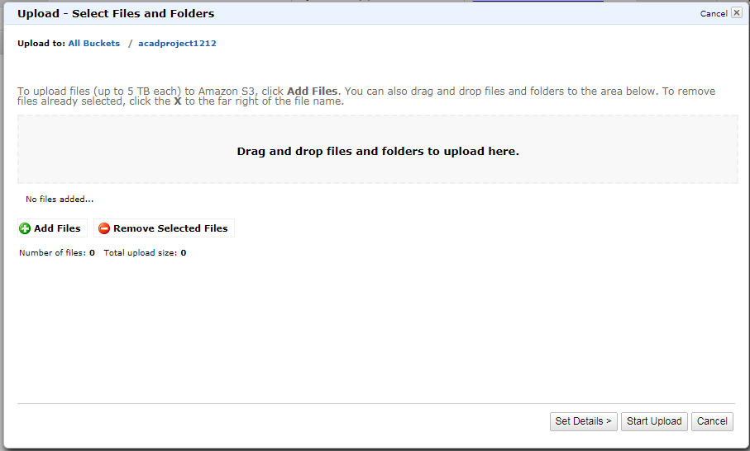

After creation of bucket, open that bucket then right click on the screen then select upload option. After that we will redirect to next page which is look like above image.

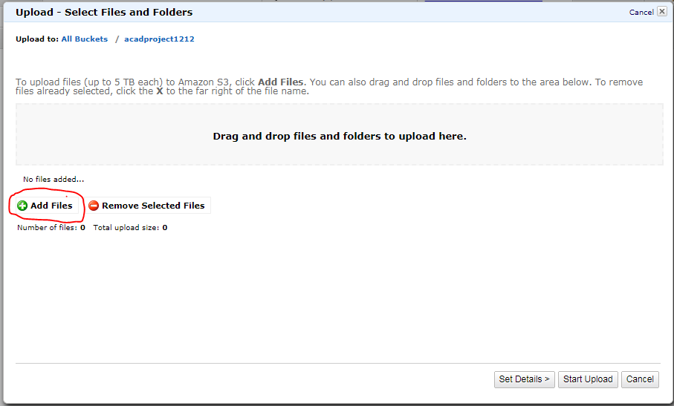

Here click on “Add files” to upload the new files into the bucket.

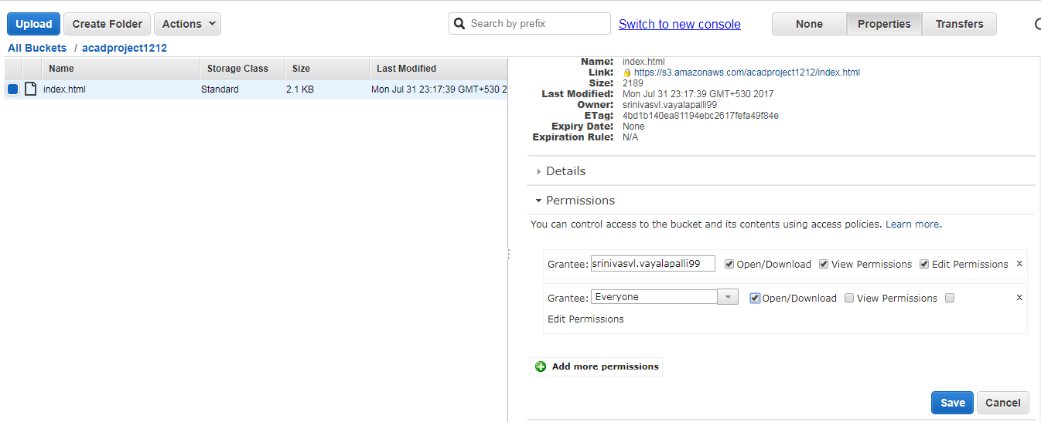

After uploaded any object into s3, it will provide on link to access that particular object.

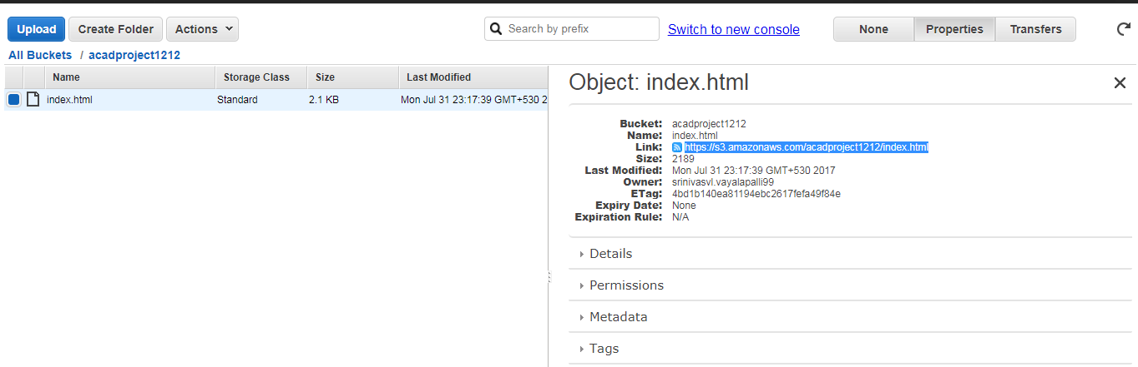

This is website, So we have to change the permission to public so that they can access the website.

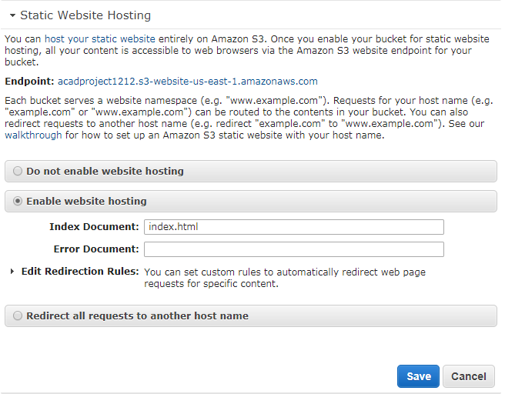

So here we will provide that html file name which is uploaded in bucket. So now if we click on that end point url which is provided by amazon s3 then we can access website as shown in below image.

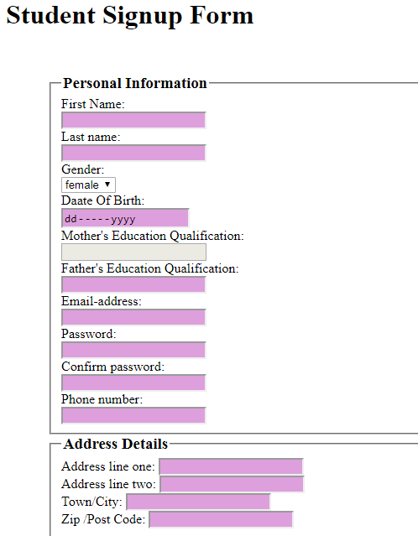

So this is the static webpage which is uploaded in s3 bucket.